Healthcare Visions, Inc. 
Creating the Possible …

1. True or False: Health plans must be required to cover mental health benefits, or else they won't.

False. Although most health plans provide limited mental health coverage, about 75% of the population in the United States has some coverage for inpatient (75.7%) and outpatient (75.6%) mental health services. While mental health benefits are generally covered, they are not generally covered at parity with medical/surgical benefits.

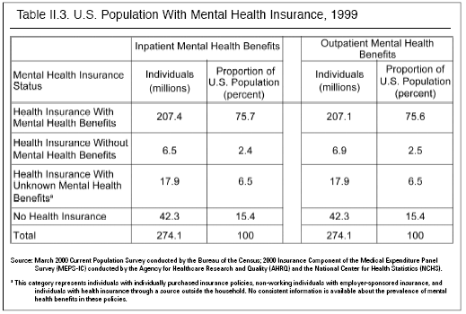

About 95% of private employer sponsored health plans (both those regulated by the Employee Retirement Income Security Act ("ERISA") and through state laws) include some kind of mental health benefit. Employees have come to expect that mental health benefits will be covered as part of their health plan, however many plans do not meet even a basic mental health benefit (30 inpatient days, 20 outpatient visits, and drug coverage).
Percent of Covered Lives
with Mental Health Benefits
Inpatient Outpatient
Benefits Benefits
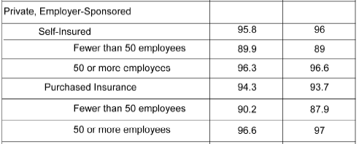
Source. National Estimates of Mental Health Insurance Benefits. U.S. Department of Health and Human Services. SAMHSA. Center for Mental Health Services. Table II.2 page 18.

For purposes of this chart, a private, employer-sponsored, self-insured plan means a health plan offered by an employer and governed under the federal Employee Retirement Income Security Act ("ERISA"). Private, employer-sponsored purchased insurance are health plans insured by carriers and regulated under state insurance laws.
- True or False: The magnitude of the mental health parity problem has been overstated. Parity between mental and physical benefits is not needed since people have sufficient mental health benefits now.

False. While employees expect to have mental health coverage, only 59.3 percent of individuals with private, employer-sponsored health insurance (provided through firms with 10 or more employees) had mental health coverage that at least met a basic "benchmark" for benefit coverage of 30 inpatient days, 20 outpatient visits and prescription drugs. (Mercer Worldwide Survey of Employer-Sponsored Health Plans--See chart below.) This benchmark level of mental health coverage is typical of many health plans, and shows that mental health coverage is much more limited than medical/surgical coverage, which typically has no day or visit limits. The chart below shows that 36.4% of individuals had mental health benefits that fell below the benchmark, and 4.3% of individuals did not have mental health benefits at all.

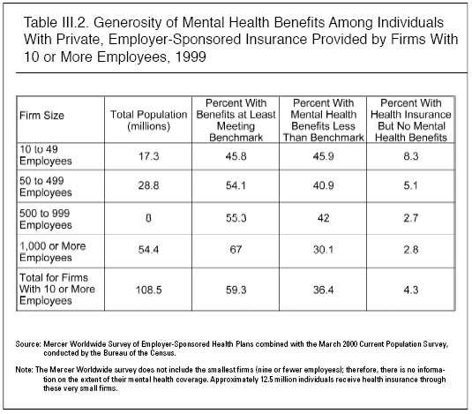
8

Similarly, a recent 2004 Kaiser Foundation Survey found that, although nearly all covered workers (98%) have mental health benefits (see Exhibit 8.2), limits on visits for outpatient care and the number of days of inpatient care remain a common feature of all plan types. (Note that this response concerns workers covered by insurance, while question one refers to those persons with inpatient and outpatient mental health benefits in the U.S. population.)

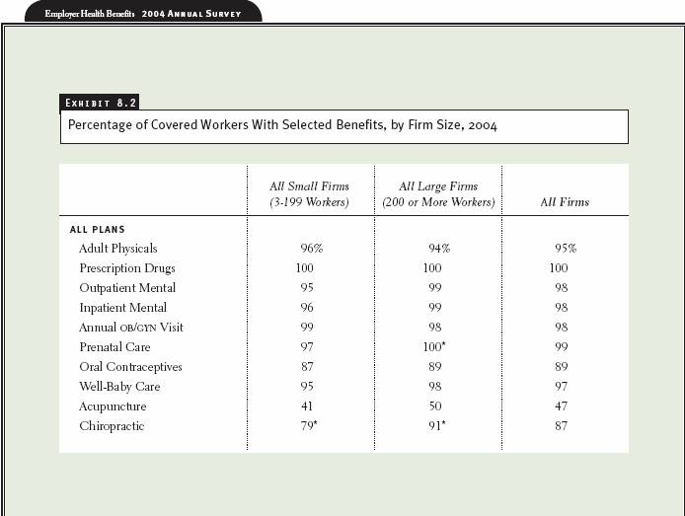

Only 19% of covered workers have coverage for an unlimited number of outpatient mental health visits in 2004, while 81% have limits on coverage. The likelihood of having a limit on the number of outpatient mental health visits is similar across plan types (see Exhibit 9.7).

Most plans limit the number of inpatient mental health days covered. Overall, only 21% of covered workers have coverage for unlimited inpatient mental health days. Approximately 59% of covered workers face an inpatient limit of 30 or fewer days (see Exhibit 9.8).

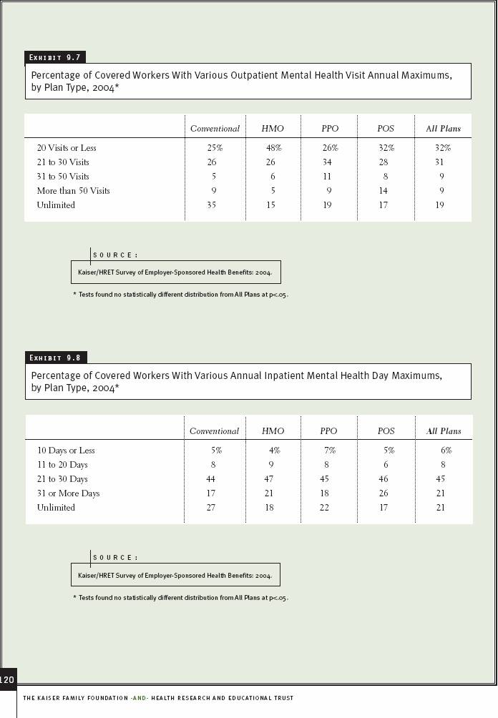

- True or False: States have already addressed the mental health parity issue so there is no longer a need for a federal mental health parity law.

False. A large number of employers that provide private health insurance coverage are self-insured, which means that the employer rather than a regulated insurance company stands behind the guarantee of benefits. Self-insured benefits are regulated by a federal law, the Employee Retirement Income Security Act (ERISA). State laws, including mental health parity and mandated benefits laws, do not apply to self-insured coverage. In order to provide mental health parity for all, a federal law is needed.

Approximately 52.0% of employees are covered under self-insured ERISA plans for a total of 43.7 million employees. The following chart shows ERISA plan membership by size of employer group.

 |  | No. of Full Time Private Sector Employees
Offered Health Insurance
(1000's)
 |  | <50 | 50-100 | 100-999 | 1000+ | Total All
Total US |  | 16820 | 5661 | 16843 | 44615 | 83995
% Self Insured |  | 3.0% | 12.0% | 48.0% | 77.0% | 52.0%
# Self Insured |  | 505 | 679 | 8085 | 34354 | 43678
% Insured |  | 97.0% | 88.0% | 52.0% | 23.0% | 48.0%
# Insured |  | 16316 | 4982 | 8759 | 10262 | 40318

Source: AHCRQ, Center for Financing, Access and Cost Trends. 2001 Medical Expenditure Panel Survey - Insurance Component.

Assuming two family members per employee, the total number of persons not directly protected by state mental health parity laws, because these laws are preempted by ERISA, is about 87.4 million lives. For your convenience I am attaching my letter to you, dated June 14, 2004, which is useful for purposes of this response in that it breaks down by state the number of lives covered under ERISA-regulated health plans.

In addition, while many states have enacted mental health parity laws, many other states have not or have enacted very limited or inadequate laws. The large states of Florida, New York, Ohio, and Michigan, and other states--Alaska, Idaho, North Dakota, Wisconsin, Wyoming, and the District of Columbia have yet to enact parity; and do not look to do so in the near future. This means that in these states more than 19.9 million workers and more than 39.8 million plan members under any type of employer-based health plan (whether regulated by ERISA or by state law) lack any protection through parity laws. Other states, including for example Arkansas and Georgia, have laws of limited application, so that few workers benefit from them.

4. True or False: A federal mental health parity law is not needed since most ERISA employer-based health plans voluntarily comply with state parity laws, even though these plans do not have to.

False. Employer-based health plans that are not required to comply with state mental health parity laws, do not provide parity coverage. A large number of employers provide private health insurance coverage that is self-insured, meaning that the employer health plan is regulated by a federal law, the Employee Retirement Income Security Act (ERISA). State laws, including mental health parity and other mandated benefits laws, do not apply to plans under ERISA.

While there is no clear demarcation between ERISA-regulated plans and state-regulated plans, a good rule of thumb is that larger plans are more likely to self-insure, which means that they are regulated by ERISA and not state law. The evidence demonstrates that larger employers are less likely to have mental health benefits on par with medical/surgical benefits. 24.2%* of members (members include spouses and children) in small groups (10-49 employees) had parity in 1999, while only 7.9% had parity in groups of 500 employees or more, representing the 62.4 million lives, a majority of those employed. Only a federal law will guarantee mental health parity coverage for most of these employees.
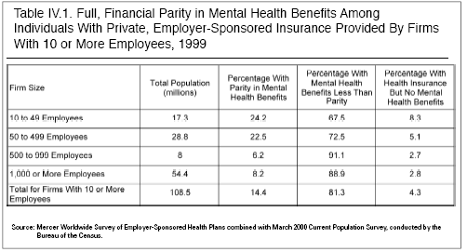
8
* The percentage of small employers covered by state parity laws has increased since 1999, with passage of several new laws.

Self-insured plans are less likely to have mental health benefits on par with medical/surgical benefits (Buck, et al. (1999)). Since fewer small firms are self-insured, smaller firms are more likely to be subject to existing state parity laws.

State laws have been effective in increasing mental health parity for members of small employer groups. Without federal parity legislation there is no way to increase parity coverage under larger self-insured employer plans, since these plans do not have to meet state parity requirements.
5. True or False: Employees are not asking for mental health parity, so they do not really care about or need it.

False. Employees clearly want and expect mental health coverage to be part of their health care benefits, and they want mental health to be covered at parity with physical health conditions. However, persons seeking and receiving mental health treatment often face or are worried about stigma and discrimination. It is difficult, if not impossible, for these persons to request expanded coverage. Privacy concerns inhibit inquiries and feedback to employers on the inadequacy of plan benefits from those receiving mental health services.

All employees, regardless of their diagnosis, expect plan coverage for medically necessary treatments. They expect coverage will provide access to care providers and financial security in time of need. There is no employee demand for coverage of new curative cancer or heart treatments, yet few employers or health plans question the inclusion of new treatments to enhance coverage. Current plan designs for physical coverage automatically and without limits include new technology, treatments, and medications, that are deemed medically necessary. Unfortunately mental health is not treated the same, hurting those persons with mental diagnoses through inequitable coverage limits that can be exhausted when protection is most needed.

Population surveys may provide some insight to coverage expectations. Below is a survey of voters from Washington State, who support mental health parity in insurance and want new laws that require it:

- More than four in five voters (86 percent) agree with the statement: state residents should get the same level of health insurance or benefits for mental illness that they get for physical health problems.
- Nearly eight in ten voters (79 percent) say they would support the legislature requiring the same level of health insurance for mental illness that residents get for physical health problems, even with slight premium increases.

Detailed poll results demonstrate strong bipartisan support for mental health parity, even when a potential cost increase is associated with parity coverage:

State residents should get the same level of health insurance
Or benefits for mental illness that they get for physical health problems.
 | All | Male | Female |  | Dem |  | Rep |  | Ind
Strongly Agree (%) | 63 | 59 | 67 | 72 |  | 56 |  | 65
Somewhat Agree (%) | 23 | 23 | 22 | 19 |  | 27 |  | 23

Would you support … having the legislature require the same level of health insurance for mental illness that residents get for physical health problems if your insurance premiums would increase by less than one percent?
 | All | Male | Female | Dem | Rep | Ind
Strongly Support (%) | 54 | 51 | 58 | 66 | 45 | 53
Somewhat Support (%) | 25 | 24 | 26 | 21 | 27 | 28

- True or False: Employees are not running up against mental health benefits limits, so a federal parity law really is not needed.

False. Employees and their families are running up against plan limits on mental health coverage and are losing the financial security that they need and expect of their insurance plan. Below is the percentage of plans with limits on either outpatient treatments or inpatient care:

 | % With O/P MH Limits | % With In/P MH Limits
One or More Limits | 89.7% | 81.7%

Source. Beneficiaries Reaching Psychiatric Benefit Limits: A Study of Employer-Sponsored Health Plans, 1997. Mary Jo Larson, Ph.D., M.P.A., New England Research Institutes, Watertown MA, Kay Miller, B.A. The MEDSTAT Group, Santa Barbara, CA

Artificial plan limits that terminate coverage for otherwise plan-accepted medically necessary treatments create a financial burden for enrollees. Treatment costs are shifted from the plan directly and fully to plan members, who may also lose plan-negotiated provider discounts and be subject to additional balance billing charges once they surpass their mental health limits.

In a 1997 study, MarketScan used the typical mental health plan design of 20 visits and 30 days to determine the percentage of patients impacted by plan design limits on mental health coverage. The results of that study showed nearly 25% of patients are impacted by plan limits on outpatient mental health care. Women are more affected than men (26.2% vs 18.7%). About 17% of patients are impacted by plan inpatient mental health limits with women again more affected than men (17.4% vs 15%).

Regarding children--according to a UCLA/Rand Research Center 1997 study, “The most vulnerable population in the current system are the sickest patients. Under existing policies, they quickly exceed their benefit and generally end up in the public sector. The calculations show that the largest increases in insurance costs as a consequence of the Mental Health Parity Act are for children, which is an important finding that has not yet received sufficient attention. Children generally have lower rates of any use, but children with mental health problems are very expensive users. Therefore, parity regarding limits for mental health or substance abuse care will primarily benefit families with seriously mentally ill children.” (Children Impacted the Most--How Expensive is Unlimited Mental Health Care Coverage Under Managed Care? UCLA/Rand. JAMA, November 1997.)

Based on MarketScan Data (1997), the average plan cost of outpatient care for those impacted by artificial plan limits is $3,692. 25% of patients under care have claims above $3,750. The average plan cost of inpatient care for those impacted by artificial plan limits is $16,651. 20% of patients under care have claims above $21,883. While these costs spread over the pool of insured lives are relatively small, the excess costs that are shifted 100% to the individual member can be financially devastating to that person and his or her family.
According to the UCLA/Rand Research Center (see chart below), 96% of all mental health claims are less than $2,500, while only 0.02% are in excess of $25,000.

Therefore, while few mental health patients generate costs in excess of $2,500, those who do can find themselves financially strapped with potentially thousands of dollars in uncovered costs for what is accepted by providers and payers to be medically necessary care to achieve recovery. Insurance is about security, protection and peace of mind. By assuring equal coverage, mental health parity legislation would ensure that enrollees with mental health diagnoses are treated fairly.

Employees and their families increased use of mental health services is evidenced by recent studies of the mental health requirement placed on health plans under the Federal Employee Health Benefit Program (FEHBP). These studies show that following parity, utilization of mental health services increased. The studies showed that when artificial limits on mental health benefits were removed more people used mental health services, and yet plan costs barely increased.

The reason for this dual effect of increased utilization and low cost impact is that more people use mental health services because parity allows mental health treatment to become more affordable--patient cost sharing requirements are reduced to match medical/surgical requirements and artificial treatment limits on inpatient and outpatient mental health care are removed. At the same time, health plan costs barely increase as plans and patients have more flexibility in using benefits, less expensive alternatives to inpatient care are emphasized and early intervention and preventive care services are promoted.

The FEHBP 2004 actuarial study of mental health and substance abuse parity commissioned by the Department of Health and Human Services (HHS) on FEHBP determined that increased utilization accounted for 28.9% of the 0.94% parity cost increase. This translates into a 15% increase in the use of mental health and substance abuse services post-parity versus pre-parity utilization. The actuarial report methodology uses actual internal historical FEBHP data for comparison of a “before period trend” to an “after period trend.”
A separate, but concurrent (HHS) 2004 statistical study of FEHBP, showed a more direct percentage increase in use from nine selected FEHBP plans as follows:

 | Adult MH/SA Use – Before and After Parity in FEHBP
 | Pre-parity Utilization % | Increase in Utilization | Percentage Change over Pre-parity Utilization
Plan 1 | 14.04% | 2.39% | 17.02%
Plan 2 | 18.71% | 1.63% | 8.70%
Plan 3 | 18.53% | 3.00% | 16.19%
Plan 4 | 15.05% | 2.49% | 16.54%
Plan 5 | 14.41% | 1.86% | 12.91%
Plan 6 | 16.12% | 2.23% | 13.83%
Plan 7 | 17.59% | 2.75% | 15.63%
Plan 8 | 15.97% | 2.64% | 16.53%
Plan 9 | 15.78% | 0.51% | 3.23%

 | Children MH/SA Use – Before and After Parity in FEHBP
 | Pre-parity Utilization % | Increase in Utilization | Percentage Change over Pre-parity Utilization
Plan 1 | 6.80% | 1.68% | 24.71%
Plan 2 | 10.12% | 2.75% | 27.17%
Plan 3 | 10.03% | 3.01% | 30.01%
Plan 4 | 5.48% | 2.28% | 41.61%
Plan 5 | 6.60% | 2.24% | 33.94%
Plan 6 | 6.10% | 1.57% | 25.74%
Plan 7 | 7.14% | 1.95% | 27.31%
Plan 8 | 5.20% | 2.11% | 40.58%
Plan 9 | 5.15% | 0.81% | 15.73%

The concurrent statistical study of the FEHBP parity data shows that adult use of mental health and substance abuse services increased under all nine plans in a range from 0.51% to 3.00%, representing a percentage change of 3.23% to 17.02% from pre-parity use rates. For children (dependents under age 18) the increase in mental health and substance abuse services ranged from 0.81% to 3.01%, representing a percentage change of 15.73% to 41.61% from pre-parity utilization. For all nine plans the increase in use by children exceeded the increase in use by adults, suggesting that children may benefit the most by the implementation of parity.

The statistical report showed that utilization of mental health and substance abuse services increased in a similar way when comparison of use trends is made to an external control group. The general trend of mental health and substance abuse utilization increases indicate a growing use of mental health services for other parity and non-parity benefit designs.

Again, it is important to remember that while utilization of services increased, the actuarial study determined an average increase in insurance costs of 0.94%, and the statistical study showed little or no cost impact: “Overall, the impact of parity policy on MH/SA service access and utilization, spending, and quality was modest.” An independent composite analysis of both studies indicates that the cost of the FEHBP implementation of mental health parity without substance abuse ranges between 0.24% and 0.87%. This minimal cost increase tracks closely with state actual experience results which show that the average cost of implementing parity is below 1%. For more on the low cost associated with mental health parity laws, see the next true or false.
7. True or False: Health plan costs increase sharply when mental health parity is required.

False. The argument that passage of mental health parity laws greatly increases plan costs has long been disproved by actual experience of states with such laws that show the average cost of implementing parity is below 1%. The reason: mental health parity requirements are a very modest extension of plan benefits, which are counterbalanced by use of benefits that emphasizes lower cost alternatives to inpatient care, early intervention and preventive care, and medication management. In other words, the marketplace has been a very efficient mechanism to address the implementation of parity so that cost increases are minimal.

There is more than ten years of documented and consistent state experience that demonstrate the minimal cost associated with passage of mental health parity laws--

- Pennsylvania – Generally less than a 0.5% cost increase. “… some carriers found the increase to be …insignificant.…”

- California - The cost of mental health parity was not a “blip on the radar screen” according to Wellpoint.

- Maryland – The cost impact was minimal for insurance plans. “Representatives from two managed care companies in Maryland stated that premiums increased by 1 percent or less....”

- Rhode Island – The cost impact was very small. “The average overall mental health cost increases resulted in an increase of total plan costs of less than 1 percent (specifically 0.33 percent of total benefit). …a managed care company observed no impact on costs… Another managed care company …observed a premium increase of less than 1%.”

- Minnesota – No noticeable increase in insurance premiums. “…health care premiums did not increase or did so by only a few percentage points.”

The Substance Abuse and Mental Health Services Administration (SAMHSA) also produced a mental health report on actual state experience and the impact on insurance premiums. This report found that, “State parity laws have had a small effect on premiums. Cost increases have been lowest in systems with tightly managed care and generous baseline benefits. Most, but not all, insurers in Maryland, Minnesota, New Hampshire, and Rhode Island reported small increases in total premium due to MH/SA parity laws.”
The states' actual experience with the low cost associated with passage of mental health parity laws will undoubtedly be reflected in federal passage of a comprehensive parity law. The Congressional Budget Office has projected that if proposed federal legislation for comprehensive mental health parity (sponsored by Senators Pete V. Domenici and Edward M. Kennedy, S. 543, 107th Congress) were enacted into law, average plan costs would increase by just 0.9%. Since this cost increase is shared by employers and employees, employers typically would pay 0.36% of the total.

Implementation of mental health parity for health plans for federal employees under FEHBP also shows an extremely low cost. A 2004 actuarial study determined an average increase in insurance costs of 0.94%, and a concurrent statistical study showed little or no cost impact: “Overall, the impact of parity policy on MH/SA service access and utilization, spending, and quality was modest.” An independent composite analysis of both studies indicates that the cost of the FEHBP implementation of mental health parity without substance abuse ranges between 0.24% and 0.87%.

Considering actual state cost experience and these reliable federal government projections, there is no evidence from any national or state study of parity that the actual insurance costs of parity are anything but minimal and within the rounding error on annual trend assumptions.

8. True or False: Employees have adequate mental health benefits now but are not using them. Rather than requiring parity coverage, it would make more sense to provide employees with better information about the benefits that are available to them now.

False. Patients are hitting plan limits on mental health coverage and losing the financial security that they need and expect from their insurance plan. Nearly 25% of patients are impacted by plan limits on outpatient mental health care. Women are more affected than men (26.2% vs 18.7%). About 17% of patients are impacted by plan limits on inpatient mental health care. Again, women are more impacted than men (17.4% vs 15%). “Children generally have lower rates of any use, but children with mental health problems are very expensive users. Therefore, parity regarding limits for mental health or substance abuse care will primarily benefit families with seriously mentally ill children.”

Of course, education and communication can always be improved when it comes to all aspects of understanding the complexities of health insurance and to help people understand the benefits that are available to them under their coverage. However, education and communication cannot change the reality of artificial financial and treatment limits imposed by employers and insurance carriers on mental health benefits for services that are recognized as medically necessary and otherwise covered under the plan.

Children Impacted the Most – How Expensive is Unlimited Mental Health Care Coverage Under Managed Care? UCLA/Rand. JAMA, November 1997.
Dept. of Health and Human Services. Evaluation of Parity in FEHBP. Tables IV B.1-9 and Tables IV.K.1-9.
The above results include substance abuse, which is not covered by the proposed national parity legislation.
Bachman, R., PricewaterhouseCoopers, Letter to Marilyn S. Richmond, July 18, 2005.
A Cost and Benefits Study of Mental Health Insurance Coverage Required by Act 1998-150. Issued by the Pennsylvania Legislative Budget and Finance Committee. May 11, 2001. PricewaterhouseCoopers.
SAMHSA - The Costs and Effects of Parity for Mental Health and Substance Abuse Insurance Benefits.
Interim Report to Congress by the National Advisory Mental Health Council
SAMHSA - The Costs and Effects of Parity for Mental Health and Substance Abuse Insurance Benefits.
SAMHSA - The Costs and Effects of Parity for Mental Health and Substance Abuse Insurance Benefits.
Bachman, R., PricewaterhouseCoopers, Letter to Marilyn S. Richmond, July 18, 2005
Children Impacted the Most – How Expensive is Unlimited Mental Health Care Coverage Under Managed Care? UCLA/Rand. JAMA, November 1997.

